Season of Interfaith Activities – Deseret News article
Jan 29,2019 Trent Toone
https://www.deseretnews.com/article/900052762/salt-lake-interfaith-roundtable-is-planning-a-season-of-activities-designed-to-highlight-different-faith-communities.html
SALT LAKE CITY — The Salt Lake Interfaith Roundtable is expanding its annual month of activities into a "season" this year to create awareness and help people learn more about the variety of faith communities in Utah.
"This year we are calling it interfaith season," said Janet Healy, chairwoman of the roundtable's planning committee. "It's a great opportunity for people to be introduced to the variety of faith communities that we have in the Salt Lake Valley. There are so many we are not aware of and it's beautiful to see that we have that many."
Starting in February, the Salt Lake Interfaith Roundtable is planning at least 12 events, two per week, leading up to its traditional Sacred Evening of Music at the Salt Lake Tabernacle at Temple Square on March 17. There is an open invitation to the public, especially families with children and college students interested in learning about other faith communities. Healy added that faith communities are also encouraged to highlight their upcoming events and facilities.
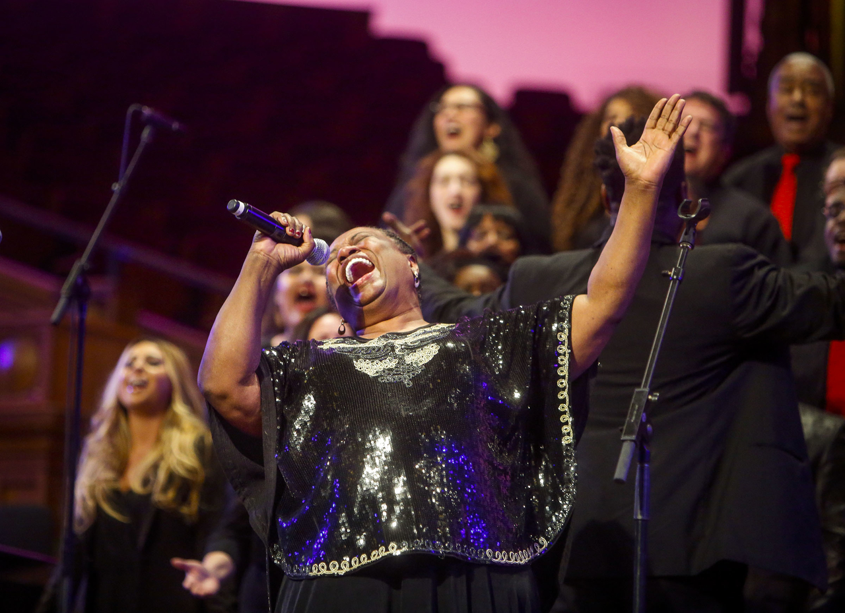
Nicole Boliaux, Deseret News
Members of the Debra Bonner Unity Gospel Choir perform during the 2017 Sacred Music Evening hosted by the Salt Lake Interfaith Roundtable in the Tabernacle on Temple Square in Salt Lake City on Sunday, March 19, 2017.
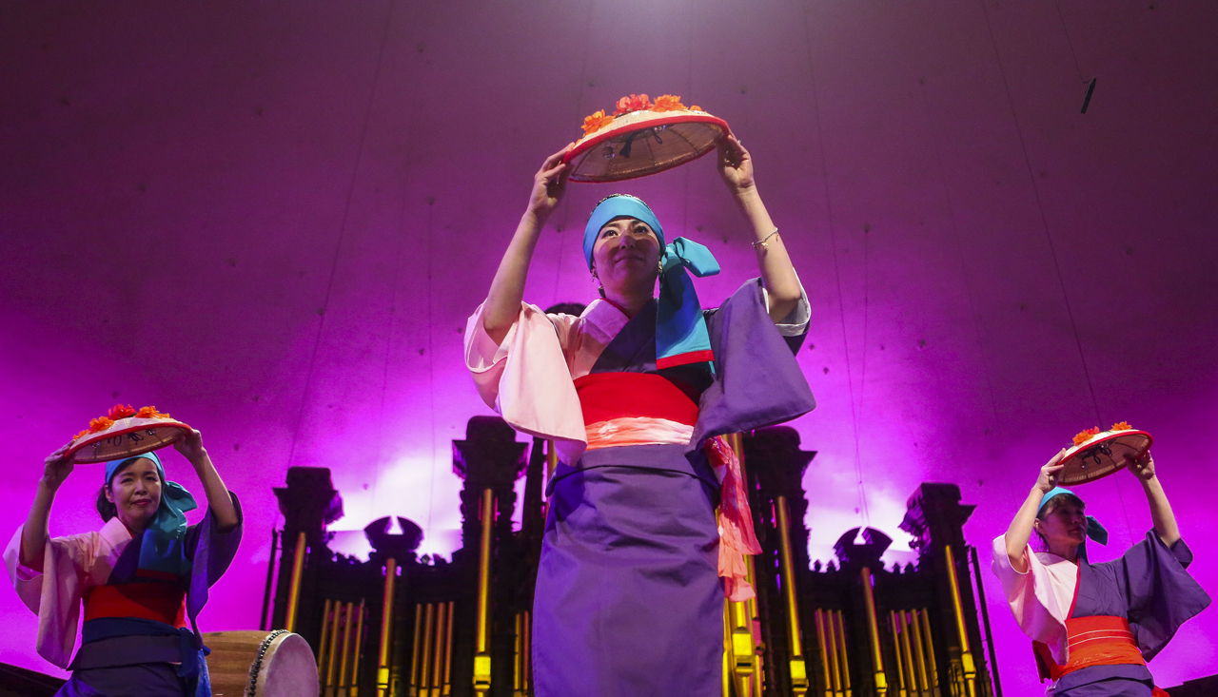
Nicole Boliaux, Deseret News
Members of the Kanako Ford and Obi Festival Dancers perform traditional folk songs and dances during the 2017 Sacred Music Evening hosted by the Salt Lake Interfaith Roundtable in the Tabernacle on Temple Square in Salt Lake City on Sunday, March 19, 2017.
Josie Stone, chairwoman of Salt Lake Interfaith Roundtable, is excited to get started.
"We are offering the community an opportunity to not only visit other places of worship but we are highlighting the work those members do to help people throughout the year, regardless of who they are," Stone said. "Our faith communities offer so much to help people in so many ways and this city and state benefits by those efforts in so many ways too, and we are richer for it. We are so very proud of our faith communities and the work they do."
Each activity builds toward the the Sacred Music Evening, organized by co-chairs Alan Bachman and Dave Sharp. The event will feature various faiths performing dances, choirs, sacred drumming and other music devotions. Free tickets are available online at lds.org but come even if you don't have tickets, Bachman said.
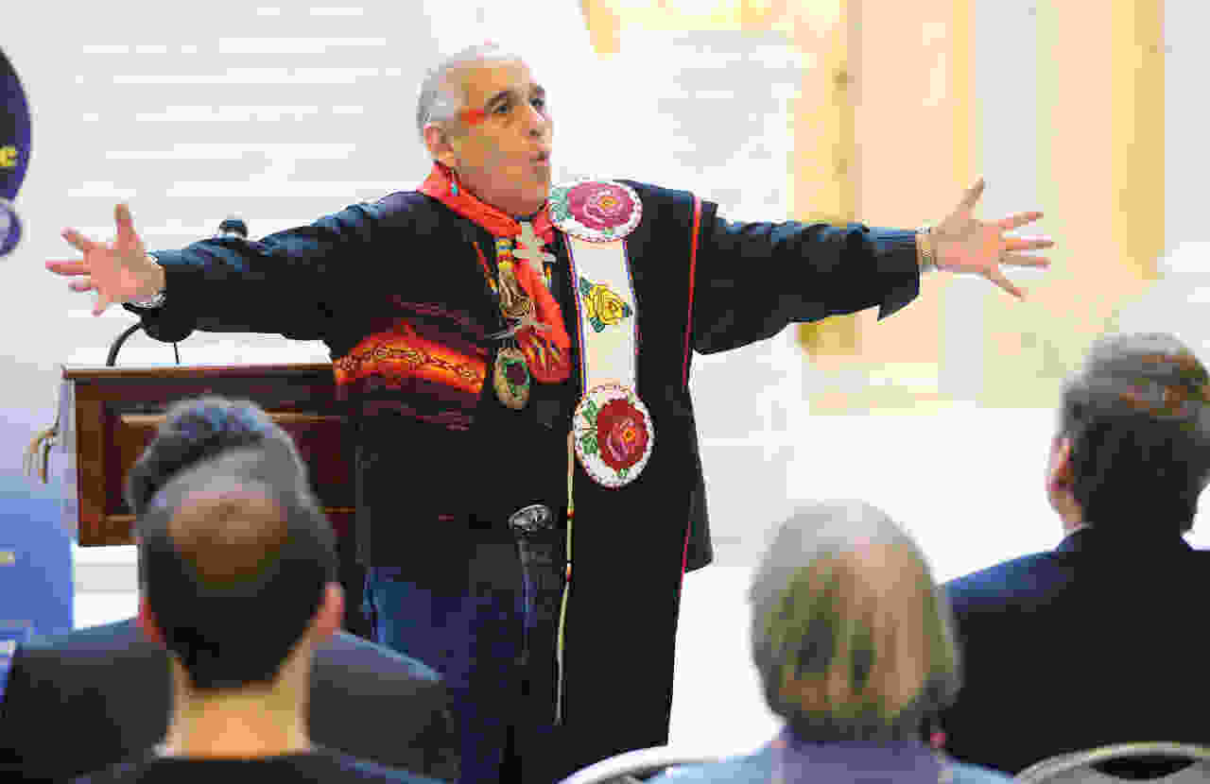
Jeffrey D. Allred, Deseret News
Northern Ute medicine man Lacee Harris speaks prior to praying during a Salt Lake Interfaith Roundtable blessing ceremony in the Capitol rotunda in Salt Lake City on Friday, Feb. 10, 2017.

Sponsored

University of Utah Health

Classic heart attack symptoms can be different for women
‹ Previous
Next ›
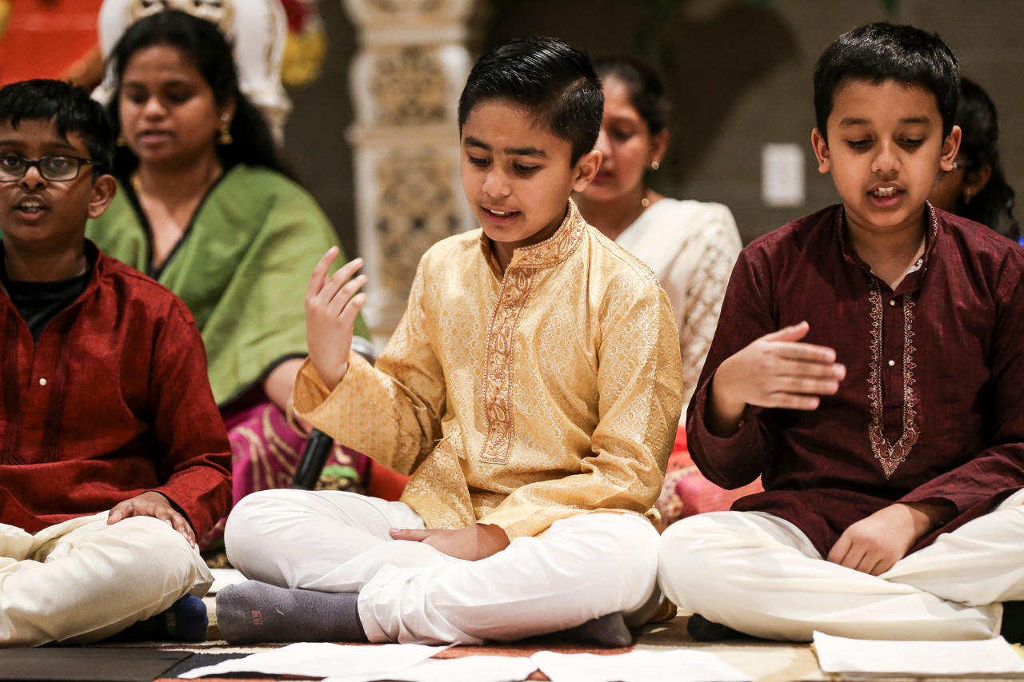
Spenser Heaps, Deseret News
Children perform a song for visitors at the Sri Ganesha Hindu Temple as part of the Interfaith Roundtable's bus tour on Tuesday, Feb. 21, 2017.
"The Sacred Music Evening is a way for our different faiths and belief systems to all come together to honor each other in one evening, which promotes harmony in the community. Our goal is to fill the Salt Lake Tabernacle," Bachman said. "If people are sitting around wondering what I can do to make the world better, come to this event. This is one thing everybody can do to make a difference and it doesn't even cost you anything."
The Sacred Music Evening is one of the interfaith roundtable's most beloved annual events, Stone said.
"The Sacred Music Evening is a perfect opportunity to showcase the vibrant talents of our faith communities, highlighting cultural, spiritual and ethnic diversity through music and dance," she said.
More information will soon be available at www.interfaithroundtable.org.
If you go ...
The calendar of Interfaith Season includes these events. They are subject to change; please see www.interfaithroundtable.org for information.
Feb. 4: Faith Expressed Through Glass, Andrew Korsorok, Cathedral of St. Marks, 231 E. 100 S., Salt Lake City, 6:30-8:30 p.m.
Feb. 8: The Messenger: Muhammed and His Life of Compassion, Emerald Hills Institute, Salt Lake Public Library, 210 E. 400 W. Salt Lake City, 3:30-5:30 p.m. (RSVP)
Feb. 13: Golden Rule Magic Show, Salt Lake Public Library, 210 E. 400 S., Salt Lake City, 6-8 p.m.
Feb. 16: Sikh event, 4897 S. Redwood Road, Salt Lake City, 5:30-7 p.m.
Feb. 19: Bus tour, The Tibetan Cultural Center, Calvary Baptist Church, 6:30-8:30 p.m. (RSVP)
Feb. 22: El Khadeeja Mosque, 1019 W. Parkway Ave., Salt Lake City, 5:30-6:30 p.m., social; 6:30-8 p.m., event.
Feb. 26: Service Project, Humanitarian Center, The Church of Jesus Christ of Latter-day Saints, 1665 S. Bennett, Salt Lake City, 2-4 p.m.
1comment on this story
Feb. 28: From Here to Eternity: Celebrating Life and Death and Faith Fair, 2425 E. Heritage Way, Salt Lake City. 6-8:30 p.m.
March 5: Shrove Tuesday Pancake Supper, Cathedral of St. Marks, 231 E. 100 S., Salt Lake City, 5 p.m.
March 11: Interfaith Open House, Sri Ganesha Hindu Temple, 1142 W. South Jordan Parkway, 6:30-8:30 p.m.
March 14: Service Project, Utah Food Bank, 6-7:30 p.m. (RSVP)
March 17: Sacred Music Evening, "Many Faiths — One Family," Salt Lake Tabernacle at Temple Square, 6 p.m.
Latter-day Saint Living Weekly newsletter
Daily LDS news headlines from the Deseret News
Sign up!
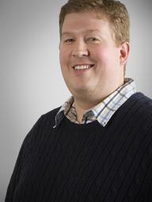
Trent TooneTrent Toone is a journalist for the Deseret News
Trent Toone
@tbtoone
ttoone@deseretnews.com

